1.

-- Prerequisite table
CREATE TABLE PATIENT (
ID NUMBER PRIMARY KEY,
NAME VARCHAR2(100) NOT NULL
);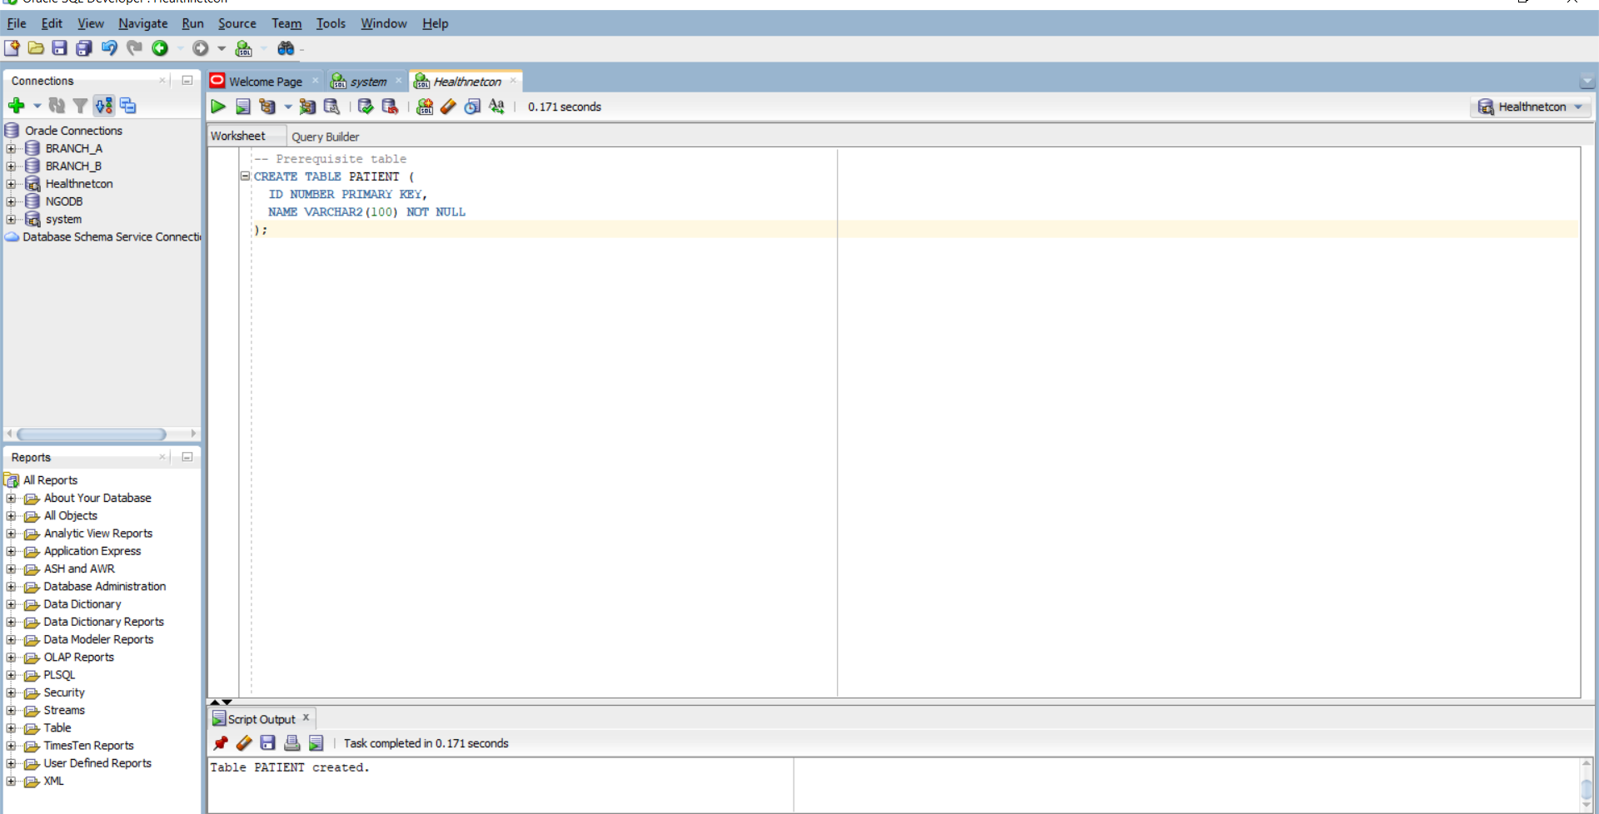

-- Corrected PATIENT_MED table
CREATE TABLE PATIENT_MED (
PATIENT_MED_ID NUMBER PRIMARY KEY, -- unique id
PATIENT_ID NUMBER NOT NULL REFERENCES PATIENT(ID), -- must reference an existing patient
MED_NAME VARCHAR2(80) NOT NULL, -- mandatory field
DOSE_MG NUMBER(6,2) CHECK (DOSE_MG >= 0), -- non-negative dose
START_DT DATE,
END_DT DATE,
CONSTRAINT CK_RX_DATES CHECK (
START_DT IS NULL OR END_DT IS NULL OR START_DT <= END_DT
) -- sensible date logic
);
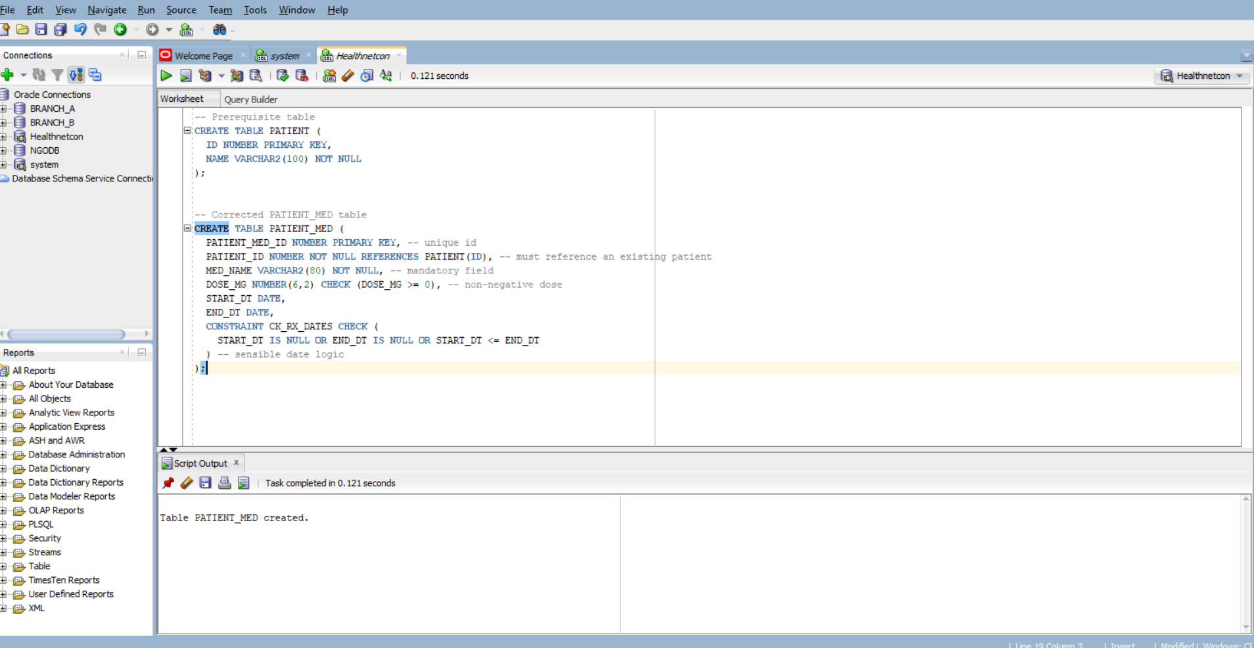

-- 1. Negative dose violates CHECK constraint
INSERT INTO PATIENT_MED VALUES (1, 1, 'Amoxicillin', -50, TO_DATE('2025-10-01','YYYY-MM-DD'), TO_DATE('2025-10-10','YYYY-MM-DD'));
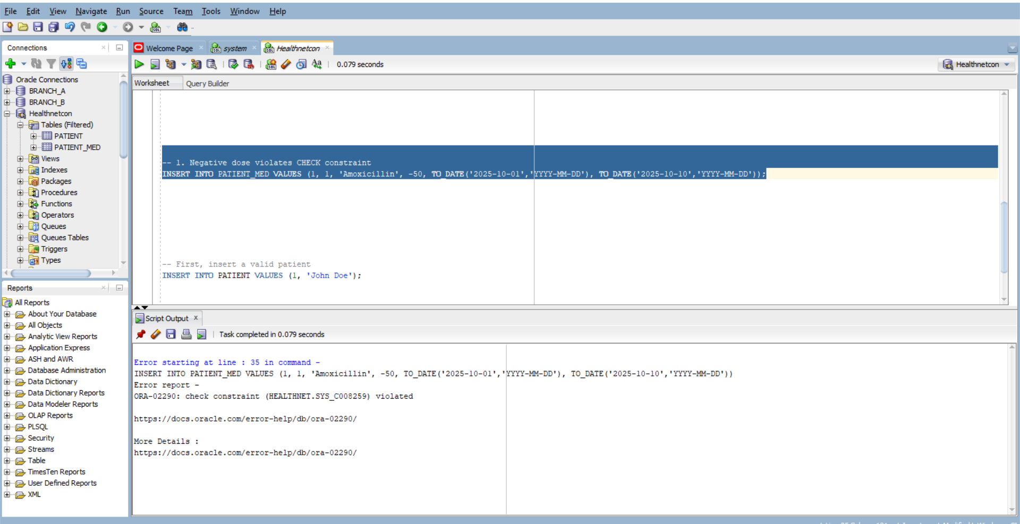

-- 2. Inverted dates violate CK_RX_DATES constraint
INSERT INTO PATIENT_MED VALUES (2, 1, 'Ibuprofen', 200, TO_DATE('2025-10-15','YYYY-MM-DD'), TO_DATE('2025-10-10','YYYY-MM-DD'));

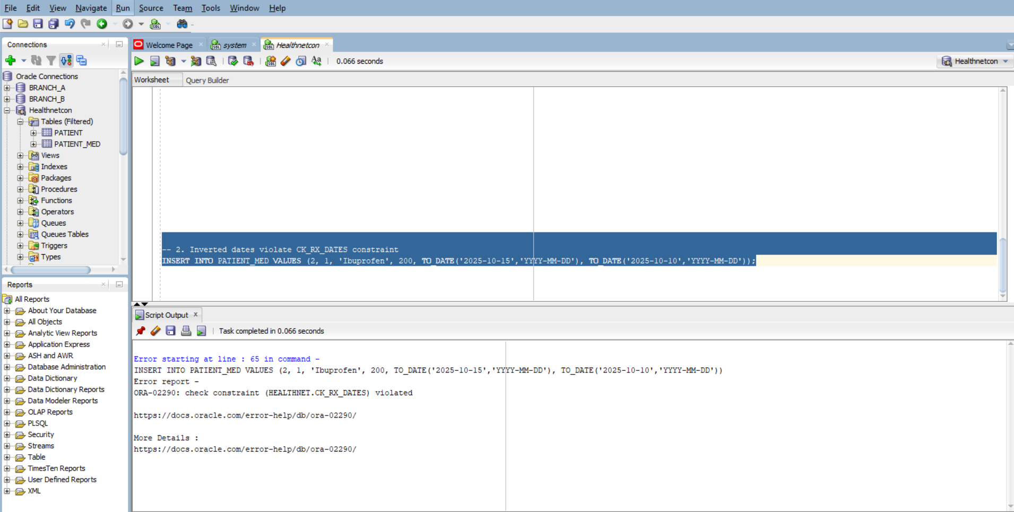

-- First, insert a valid patient
INSERT INTO PATIENT VALUES (1, 'John Doe');

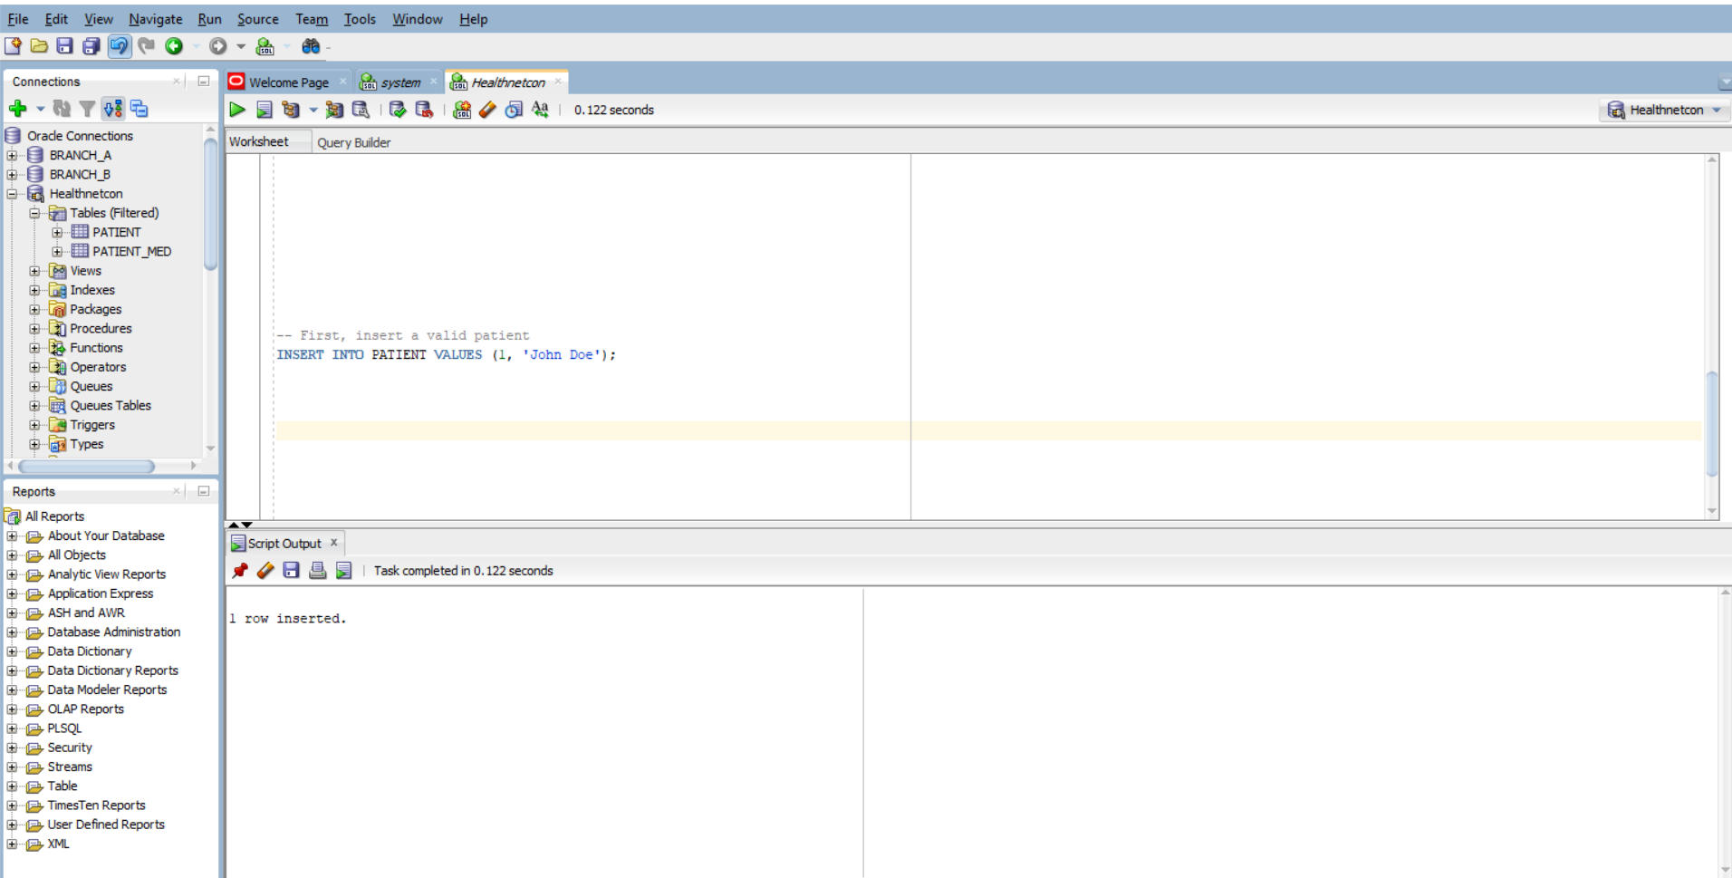

-- 1. Valid prescription
INSERT INTO PATIENT_MED VALUES (3, 1, 'Paracetamol', 500, TO_DATE('2025-10-01','YYYY-MM-DD'), TO_DATE('2025-10-05','YYYY-MM-DD'));
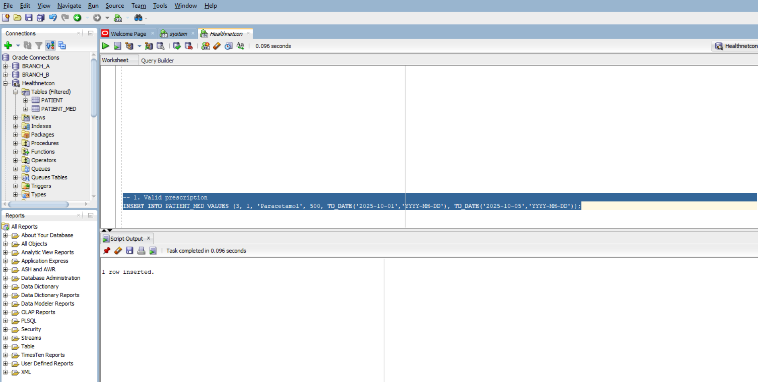

-- 2. Valid prescription with NULL dates
INSERT INTO PATIENT_MED VALUES (4, 1, 'Cetirizine', 10, NULL, NULL);

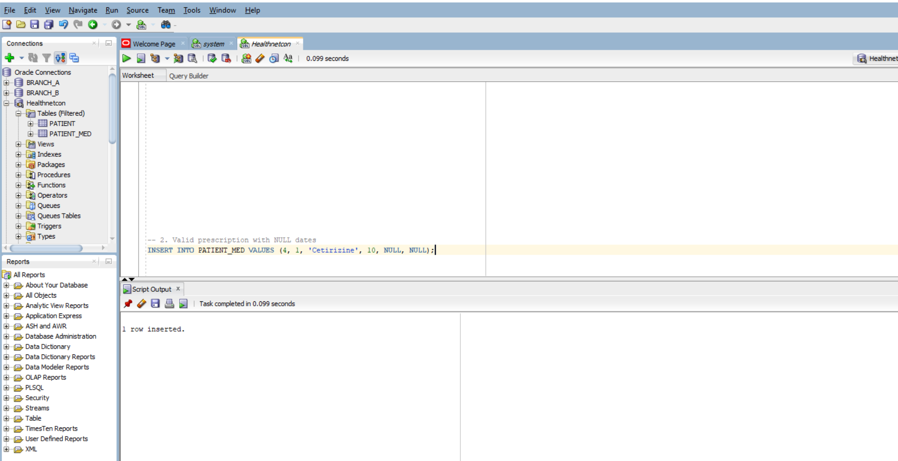
select * from patient_med;
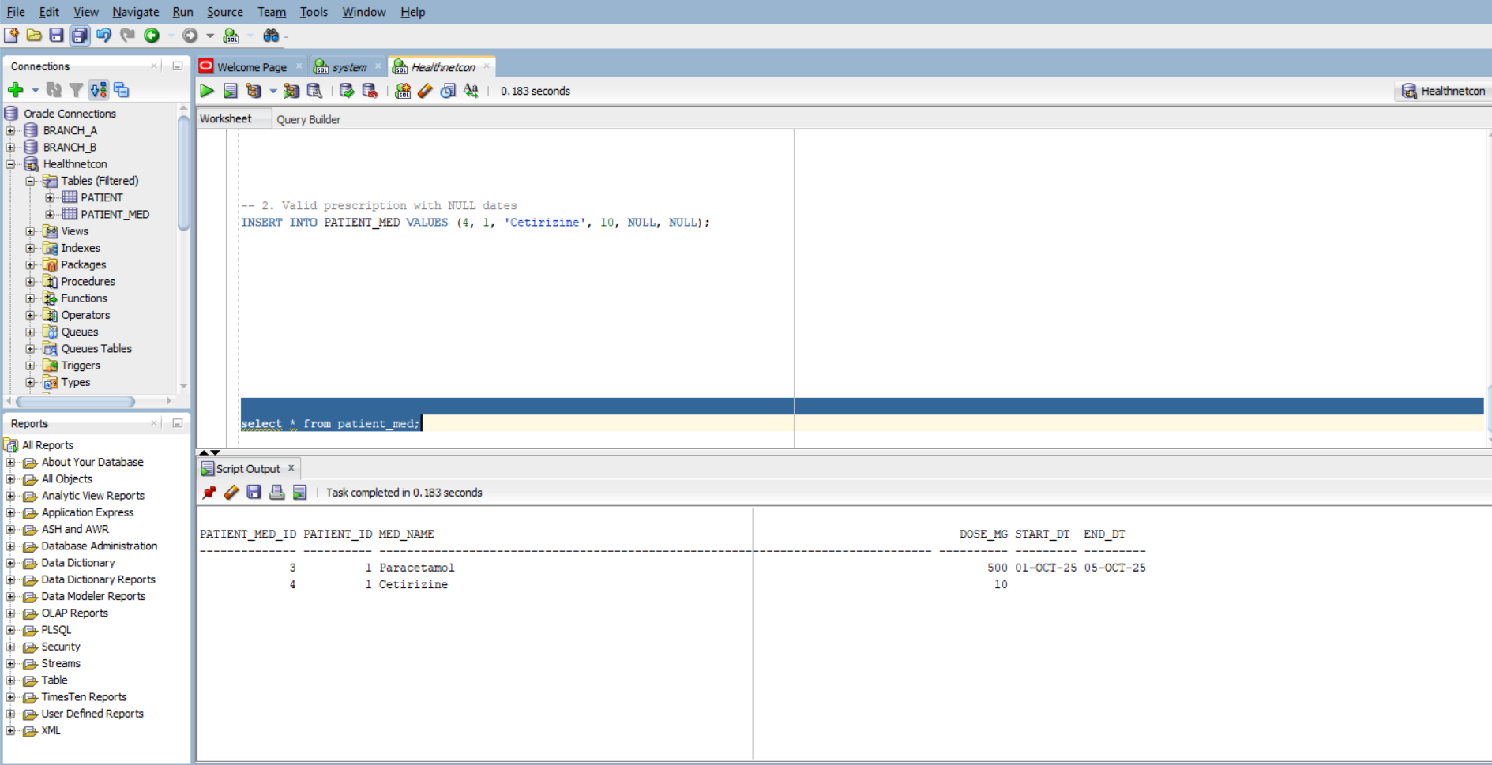

Error Type | Buggy Code | Correction | Explanation
Missing commas | No commas between column definitions | Added commas between each column definition | SQL requires commas to separate columns in a CREATE TABLE statement
Missing NOT NULL | MED_NAME VARCHAR2(80) | MED_NAME VARCHAR2(80) NOT NULL | Ensures MED_NAME is mandatory
Malformed CHECK clause | DOSE_MG NUMBER(6,2) CHECK DOSE_MG >= 0 | DOSE_MG NUMBER(6,2) CHECK (DOSE_MG >= 0) | CHECK constraints must be enclosed in parentheses
Invalid date logic | CHECK (START_DT <= END_DT WHEN BOTH NOT NULL) | CHECK (START_DT IS NULL OR END_DT IS NULL OR START_DT <= END_DT) | SQL doesn't support "WHEN BOTH NOT NULL"; use logical OR to allow NULLs
Missing NOT NULL on FK | PATIENT_ID NUMBER REFERENCES PATIENT(ID) | PATIENT_ID NUMBER NOT NULL REFERENCES PATIENT(ID) | Ensures foreign key is mandatory
2. -- Main bill table
CREATE TABLE BILL (
ID NUMBER PRIMARY KEY,
TOTAL NUMBER(12,2)
);

-- Items linked to bills
CREATE TABLE BILL_ITEM (
BILL_ID NUMBER,
AMOUNT NUMBER(12,2),
UPDATED_AT DATE,
CONSTRAINT FK_BILL_ITEM_BILL FOREIGN KEY (BILL_ID) REFERENCES BILL(ID)
);

-- Audit log for changes
CREATE TABLE BILL_AUDIT (
BILL_ID NUMBER,
OLD_TOTAL NUMBER(12,2),
NEW_TOTAL NUMBER(12,2),
CHANGED_AT DATE
);

Correct Compound Trigger: TRG_BILL_TOTAL_CMP: it updates BILL.TOTAL once per statement and logs changes into BILL_AUDIT, avoiding mutating-table errors and redundant updates.

CREATE OR REPLACE TRIGGER TRG_BILL_TOTAL_STMT
AFTER INSERT OR UPDATE OR DELETE ON BILL_ITEM
DECLARE
TYPE bill_id_table IS TABLE OF BILL_ITEM.BILL_ID%TYPE INDEX BY PLS_INTEGER;
v_bill_ids bill_id_table;
v_index PLS_INTEGER := 0;
BEGIN
-- Collect affected BILL_IDs
FOR r IN (
SELECT DISTINCT BILL_ID FROM BILL_ITEM
WHERE BILL_ID IS NOT NULL
) LOOP
v_index := v_index + 1;
v_bill_ids(v_index) := r.BILL_ID;
END LOOP;

-- Recompute totals and insert audit rows
FOR i IN 1 .. v_index LOOP
DECLARE
v_old_total BILL.TOTAL%TYPE;
v_new_total BILL.TOTAL%TYPE;
BEGIN
SELECT TOTAL INTO v_old_total FROM BILL WHERE ID = v_bill_ids(i);
SELECT NVL(SUM(AMOUNT), 0) INTO v_new_total FROM BILL_ITEM WHERE BILL_ID = v_bill_ids(i);

UPDATE BILL SET TOTAL = v_new_total WHERE ID = v_bill_ids(i);

INSERT INTO BILL_AUDIT (BILL_ID, OLD_TOTAL, NEW_TOTAL, CHANGED_AT)
VALUES (v_bill_ids(i), v_old_total, v_new_total, SYSDATE);
END;
END LOOP;
END;
/
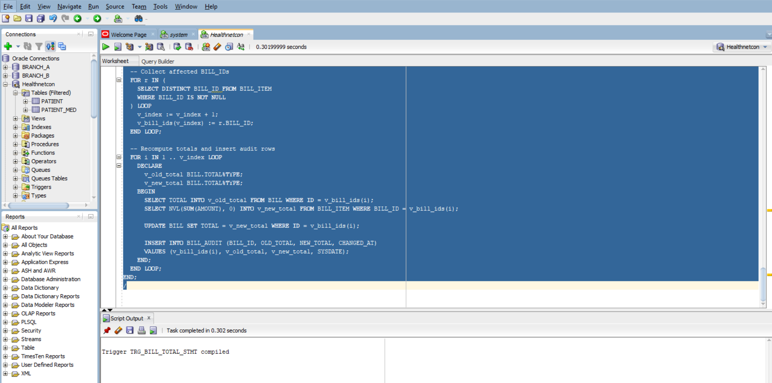

-- Insert bill items (trigger fires here)
INSERT INTO BILL_ITEM VALUES (1, 100, SYSDATE);
INSERT INTO BILL_ITEM VALUES (1, 200, SYSDATE);
INSERT INTO BILL_ITEM VALUES (2, 300, SYSDATE);
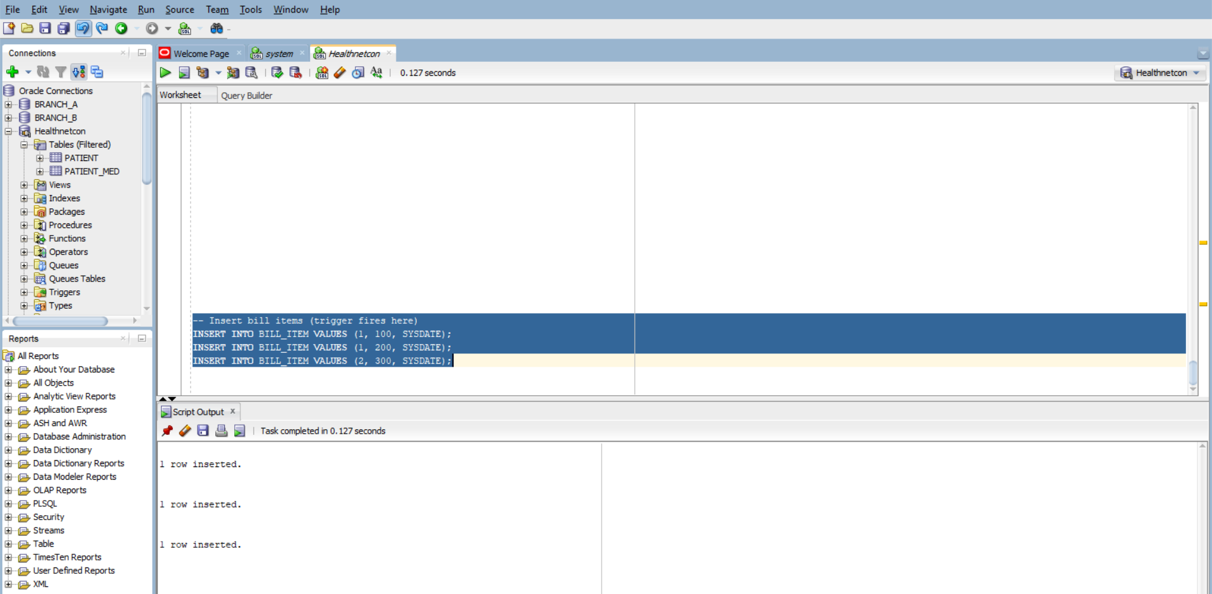

-- Update an item (trigger fires)
UPDATE BILL_ITEM SET AMOUNT = 150 WHERE BILL_ID = 1 AND AMOUNT = 100;

-- Delete an item (trigger fires)
DELETE FROM BILL_ITEM WHERE BILL_ID = 2 AND AMOUNT = 300;
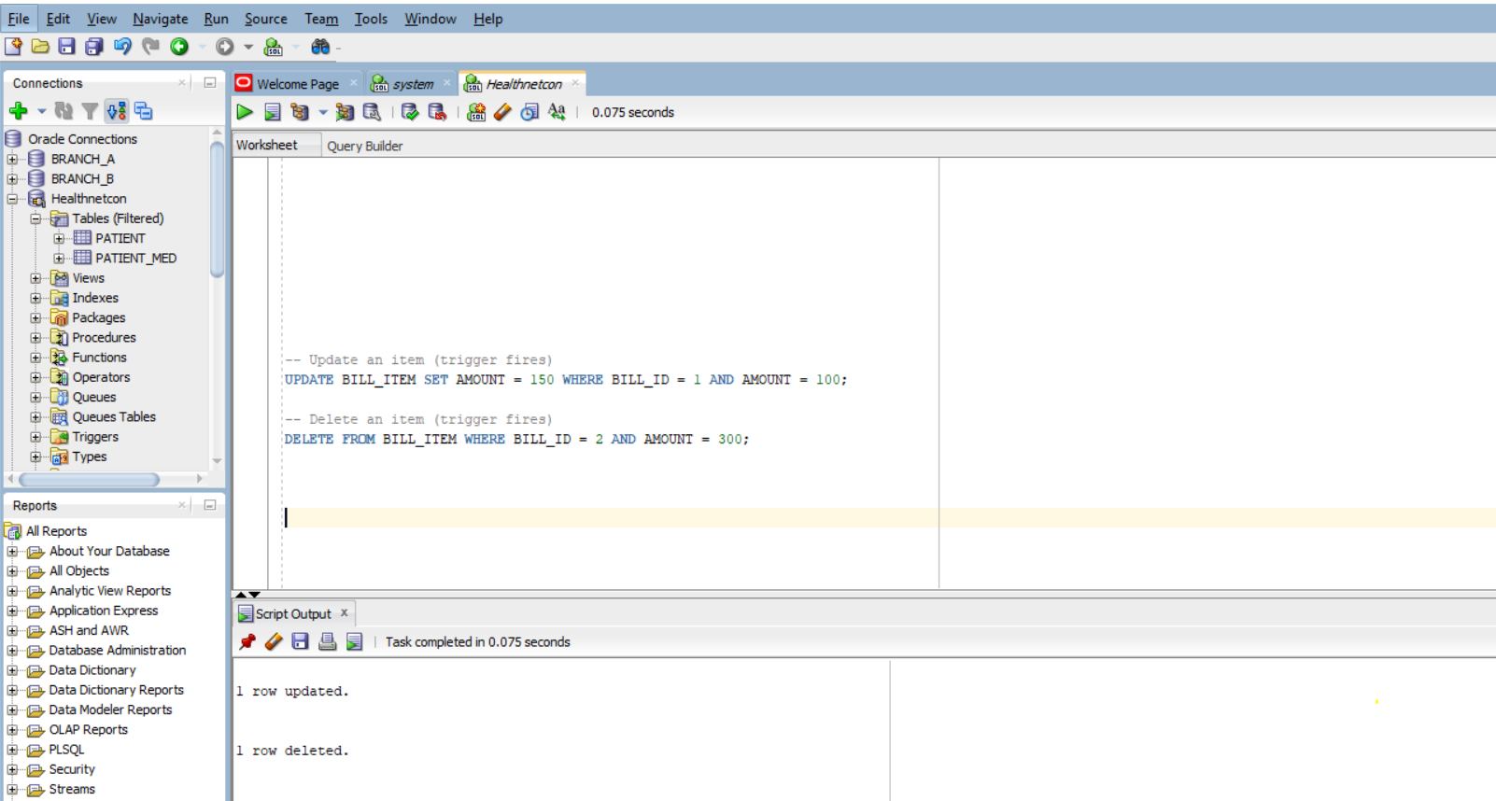

-- Check updated totals
SELECT * FROM BILL;

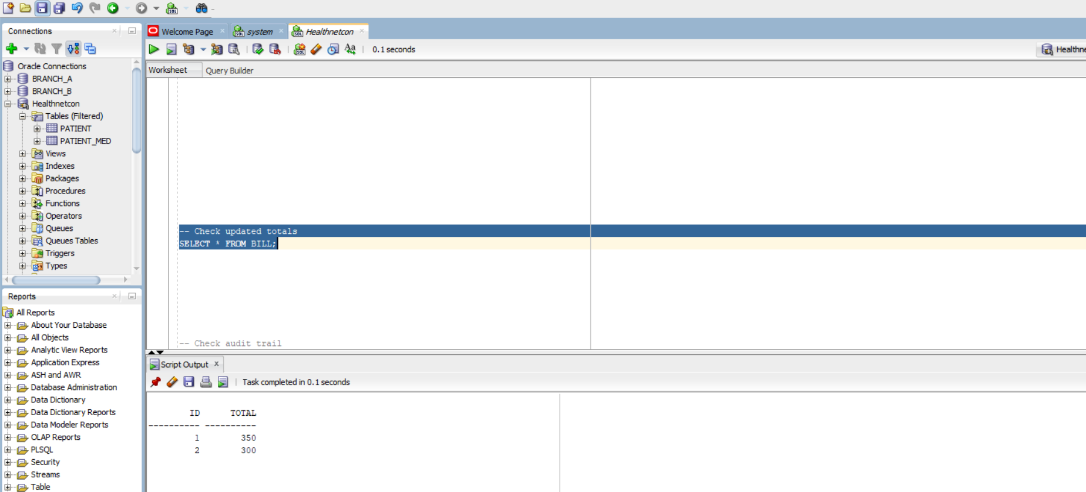

-- Check audit trail
SELECT * FROM BILL_AUDIT ORDER BY CHANGED_AT;
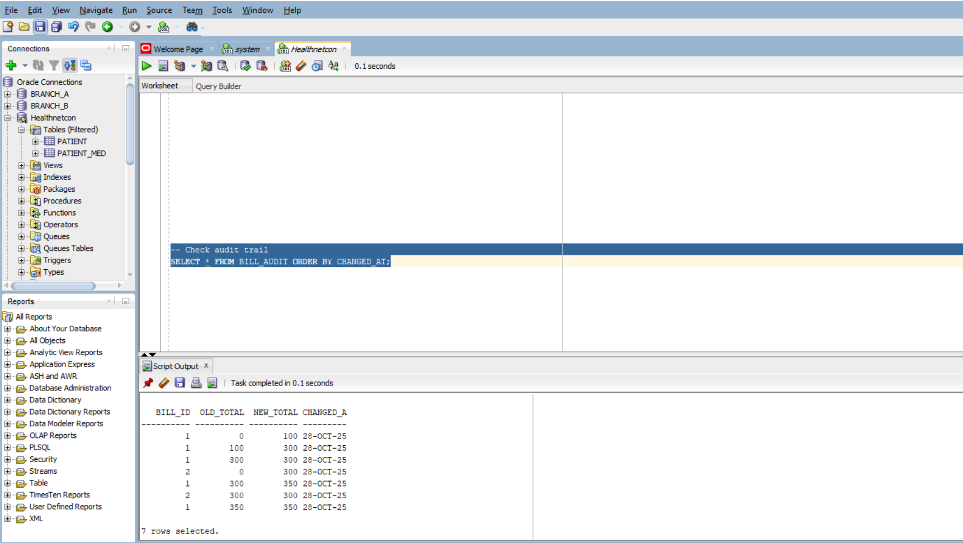

- BILL.TOTAL for ID 1 should reflect the sum of its items (e.g., 150 + 200 = 350).
- BILL.TOTAL for ID 2 should be 0 after deletion.
- BILL_AUDIT should show old and new totals for each change.
3.
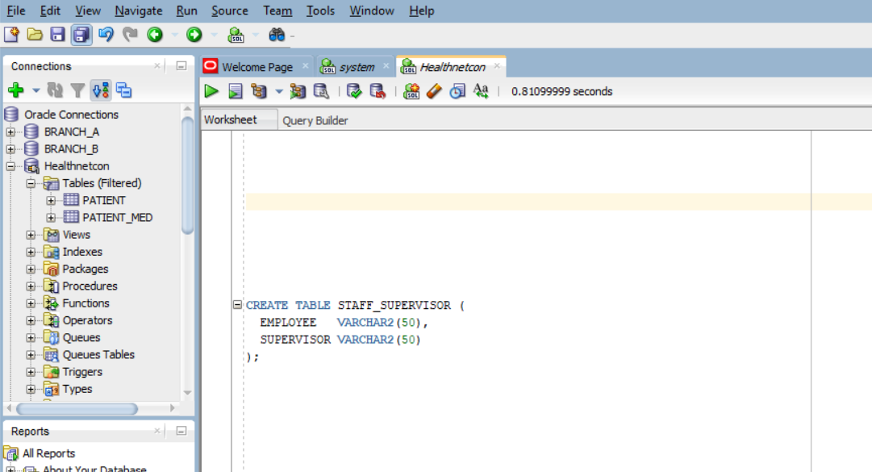

Inserting rows
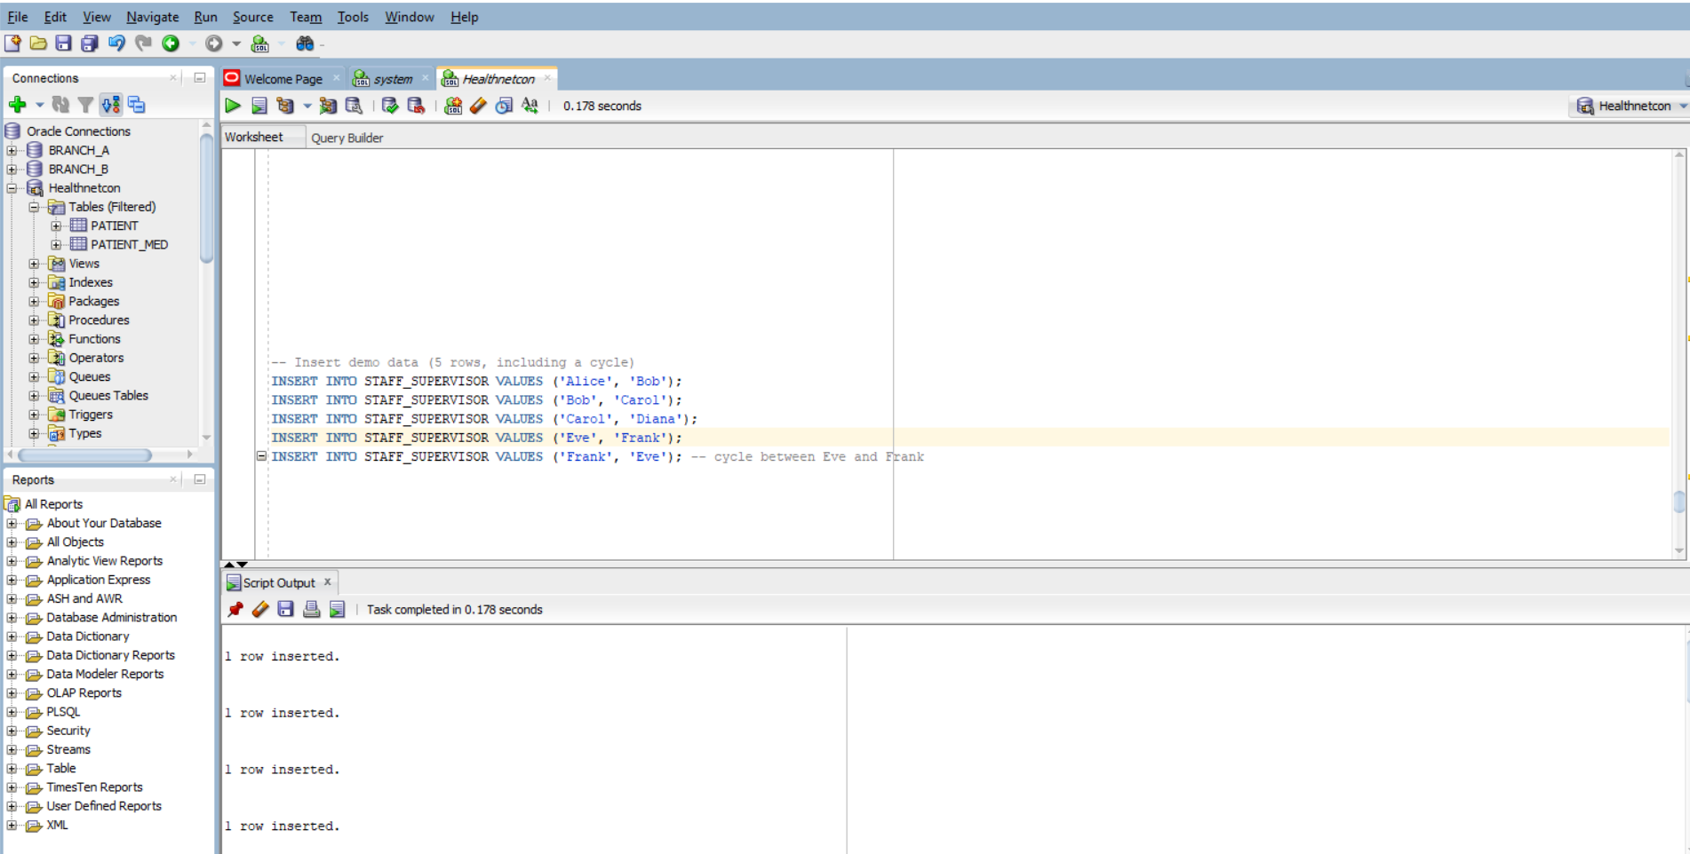

-- Corrected recursive query
WITH SUPERS (EMP, SUP, HOPS, PATH) AS (
-- Anchor: start with direct supervision, hop count = 1
SELECT EMPLOYEE, SUPERVISOR, 1, EMPLOYEE || '>' || SUPERVISOR
FROM STAFF_SUPERVISOR
UNION ALL
-- Recursive: climb up the supervision chain
SELECT S.EMPLOYEE, T.SUP, T.HOPS + 1, T.PATH || '>' || T.SUP
FROM STAFF_SUPERVISOR S
JOIN SUPERS T ON S.SUPERVISOR = T.EMP
WHERE INSTR(T.PATH, T.SUP) = 0 -- cycle guard
)
-- Final selection: top supervisor per employee
SELECT EMP, SUP AS TOP_SUPERVISOR, HOPS
FROM (
SELECT EMP, SUP, HOPS,
RANK() OVER (PARTITION BY EMP ORDER BY HOPS DESC) AS RANK
FROM SUPERS
)
WHERE RANK = 1;
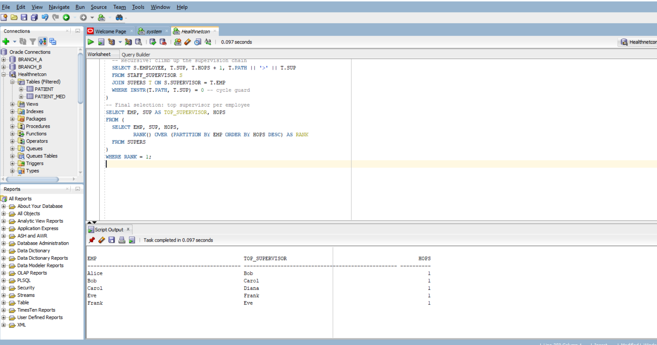
Bug | Fix
Anchor hop count was 0 | Set to 1 to reflect first supervision step
Join direction was reversed | Corrected to climb up: S.SUPERVISOR = T.EMP
Cycle guard was naive | Improved with INSTR(PATH, T.SUP) = 0
Scalar subquery with MAX(HOPS or the number of steps it takes to reach an employee’s top supervisor by following the chain of supervision) | Replaced with RANK() analytic function for clarity and correctness
Diana
└── Carol
└── Bob
└── Alice

Eve ↔ Frank (cycle)

4.

CREATE TABLE TRIPLE (
S VARCHAR2(100),
P VARCHAR2(50),
O VARCHAR2(100)
);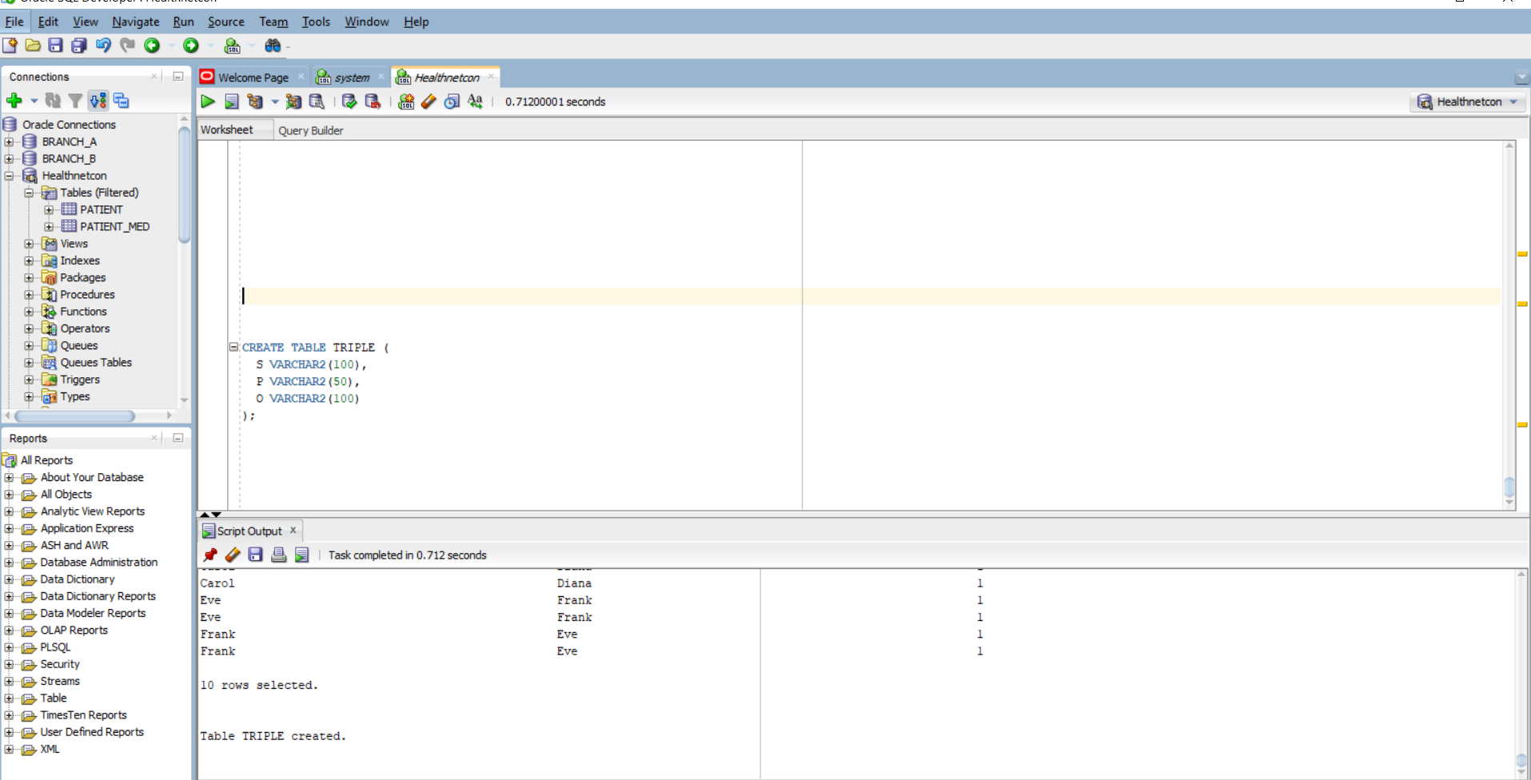

-- Patient diagnoses
INSERT INTO TRIPLE VALUES ('patient1', 'hasDiagnosis', 'Influenza');
INSERT INTO TRIPLE VALUES ('patient2', 'hasDiagnosis', 'COVID19');
INSERT INTO TRIPLE VALUES ('patient3', 'hasDiagnosis', 'Malaria');
INSERT INTO TRIPLE VALUES ('patient4', 'hasDiagnosis', 'Diabetes');

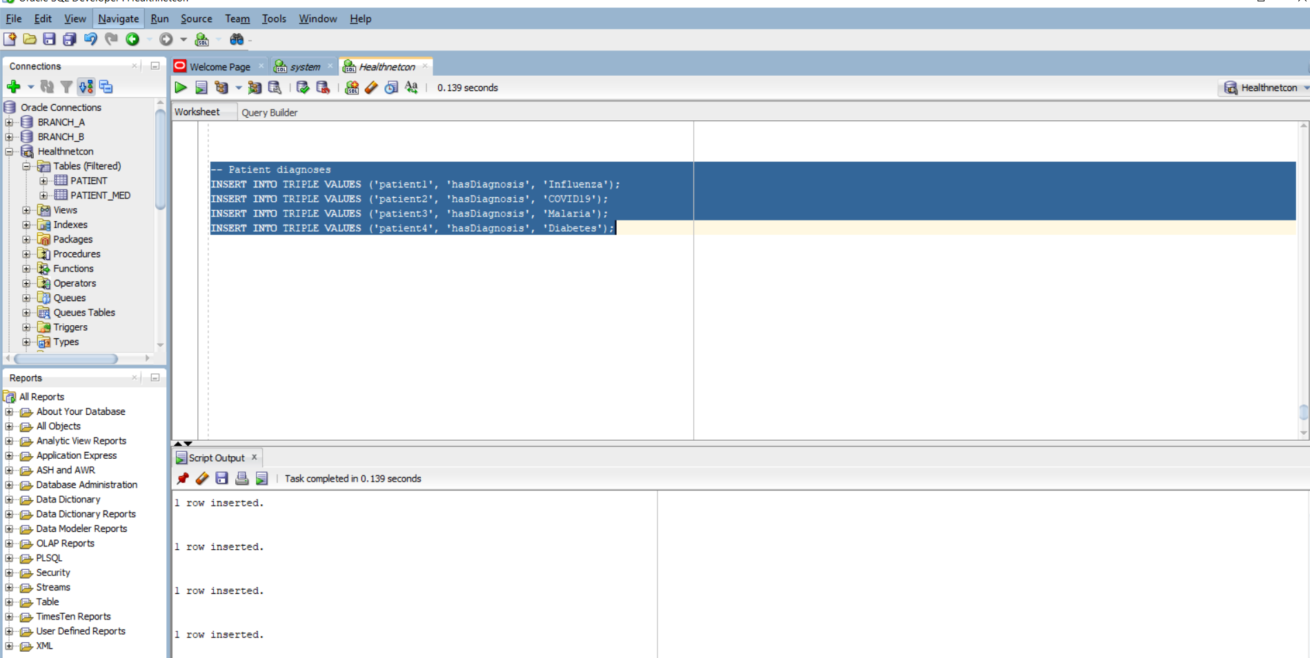
-- Taxonomy edges
INSERT INTO TRIPLE VALUES ('Influenza', 'isA', 'ViralInfection');
INSERT INTO TRIPLE VALUES ('COVID19', 'isA', 'ViralInfection');
INSERT INTO TRIPLE VALUES ('Malaria', 'isA', 'ParasiticInfection');
INSERT INTO TRIPLE VALUES ('ViralInfection', 'isA', 'InfectiousDisease');
INSERT INTO TRIPLE VALUES ('ParasiticInfection', 'isA', 'InfectiousDisease');
INSERT INTO TRIPLE VALUES ('Diabetes', 'isA', 'ChronicDisease');

Check inserted rows;
select * from triple;
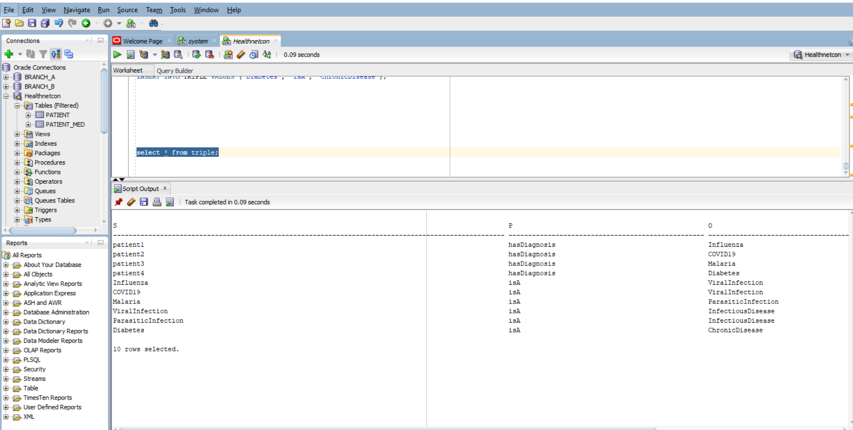
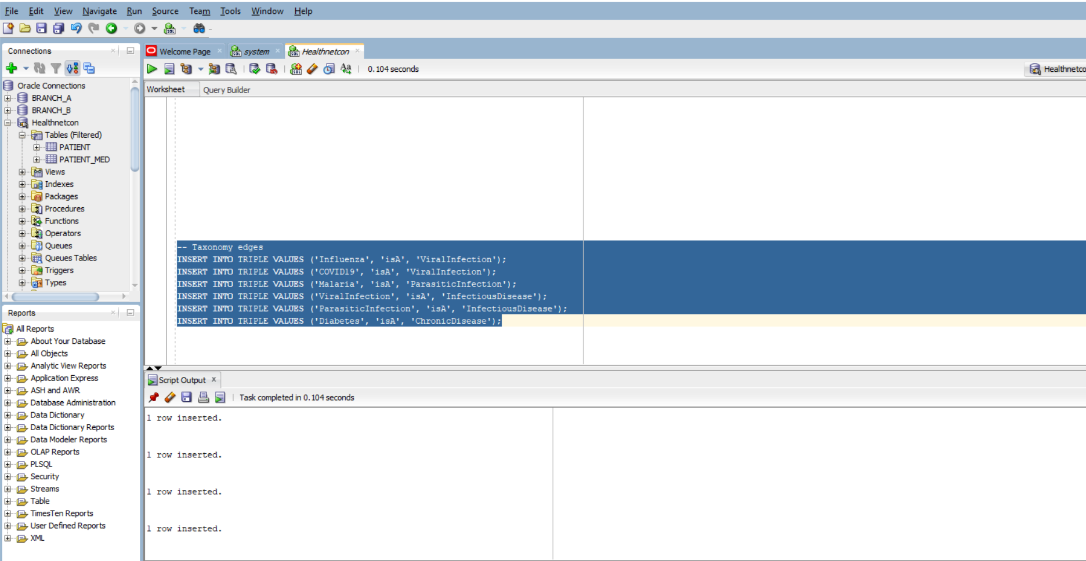

WITH ISA(ANCESTOR, CHILD) AS (
-- Anchor: direct isA relationships
SELECT O, S FROM TRIPLE WHERE P = 'isA'
UNION ALL
-- Recursive: climb up the taxonomy
SELECT I.ANCESTOR, T.S
FROM TRIPLE T
JOIN ISA I ON T.P = 'isA' AND T.O = I.CHILD
),
INFECTIOUS_PATIENTS AS (
SELECT DISTINCT T.S
FROM TRIPLE T
JOIN ISA ON T.O = ISA.CHILD
WHERE T.P = 'hasDiagnosis'
AND ISA.ANCESTOR = 'InfectiousDisease'
)
SELECT S AS PATIENT_ID FROM INFECTIOUS_PATIENTS;
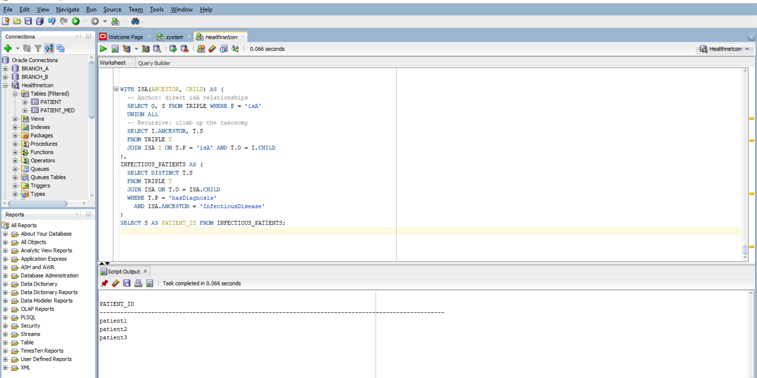

• Represent facts in a flexible, searchable format
• Link concepts together (like diseases to categories)
• Enable reasoning and inference (e.g., if Influenza is an InfectiousDisease, then patient1 has an InfectiousDisease)

5.

-- Create clinic table with spatial geometry
CREATE TABLE CLINIC (
ID NUMBER PRIMARY KEY,
NAME VARCHAR2(100),
GEOM SDO_GEOMETRY
);

INSERT INTO USER_SDO_GEOM_METADATA
(TABLE_NAME, COLUMN_NAME, DIMINFO, SRID)
VALUES (
'CLINIC',
'GEOM',
SDO_DIM_ARRAY(
SDO_DIM_ELEMENT('Longitude', 30.0, 31.0, 0.005),
SDO_DIM_ELEMENT('Latitude', -2.5, -1.5, 0.005)
),
4326
);
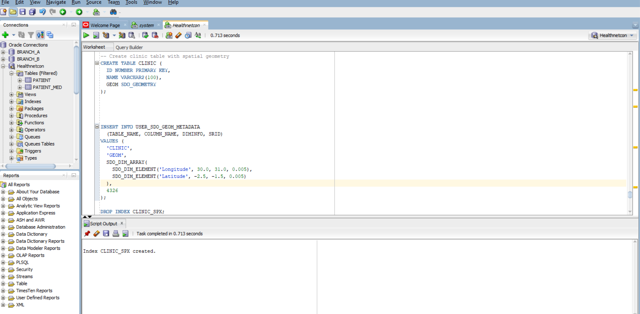

-- Create spatial index
CREATE INDEX CLINIC_SPX ON CLINIC(GEOM)
INDEXTYPE IS MDSYS.SPATIAL_INDEX;

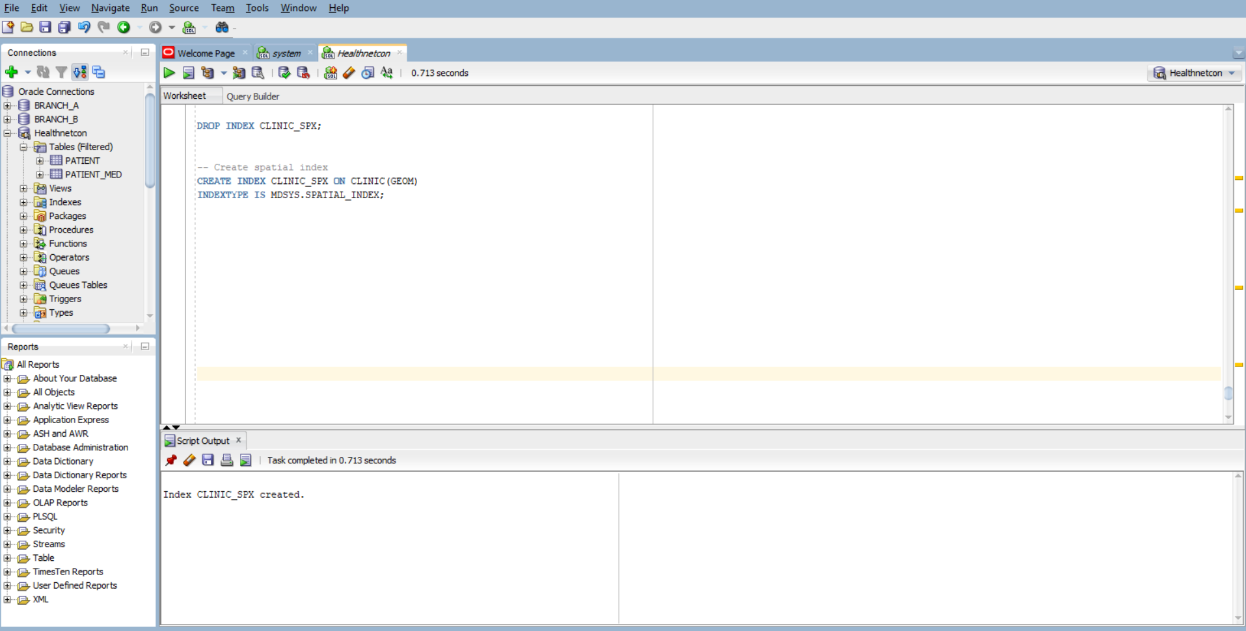

-- Ambulance is at (30.0600, -1.9570)
INSERT INTO CLINIC VALUES (
1, 'Kigali Central Clinic',
SDO_GEOMETRY(2001, 4326, SDO_POINT_TYPE(30.0610, -1.9575, NULL), NULL, NULL)
);

INSERT INTO CLINIC VALUES (
2, 'Nyamirambo Health Center',
SDO_GEOMETRY(2001, 4326, SDO_POINT_TYPE(30.0595, -1.9560, NULL), NULL, NULL)
);

INSERT INTO CLINIC VALUES (
3, 'Gikondo Medical',
SDO_GEOMETRY(2001, 4326, SDO_POINT_TYPE(30.0700, -1.9500, NULL), NULL, NULL)
);

COMMIT; 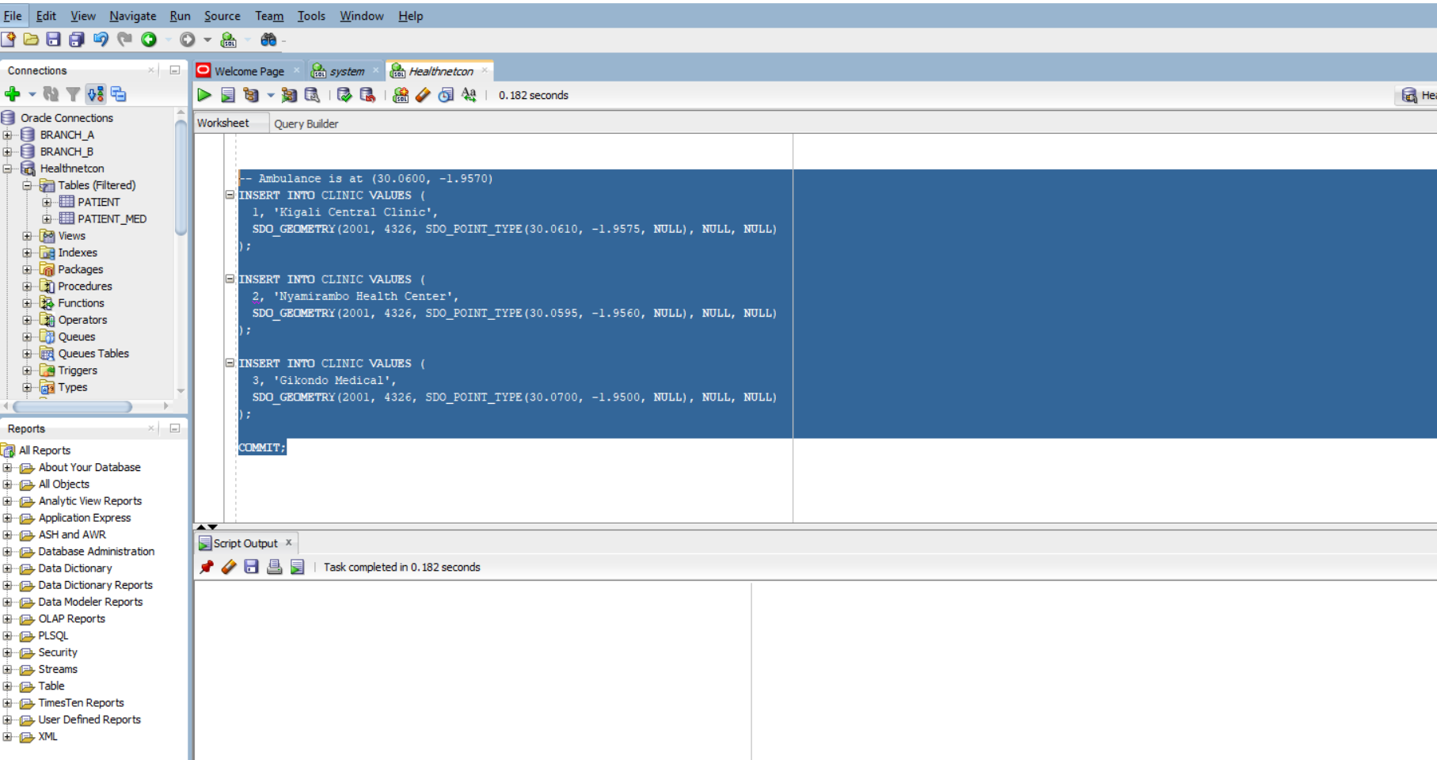

SELECT C.ID, C.NAME
FROM CLINIC C
WHERE SDO_WITHIN_DISTANCE(
C.GEOM,
SDO_GEOMETRY(2001, 4326, SDO_POINT_TYPE(30.0600, -1.9570, NULL), NULL, NULL),
'distance=1 unit=KM'
) = 'TRUE';

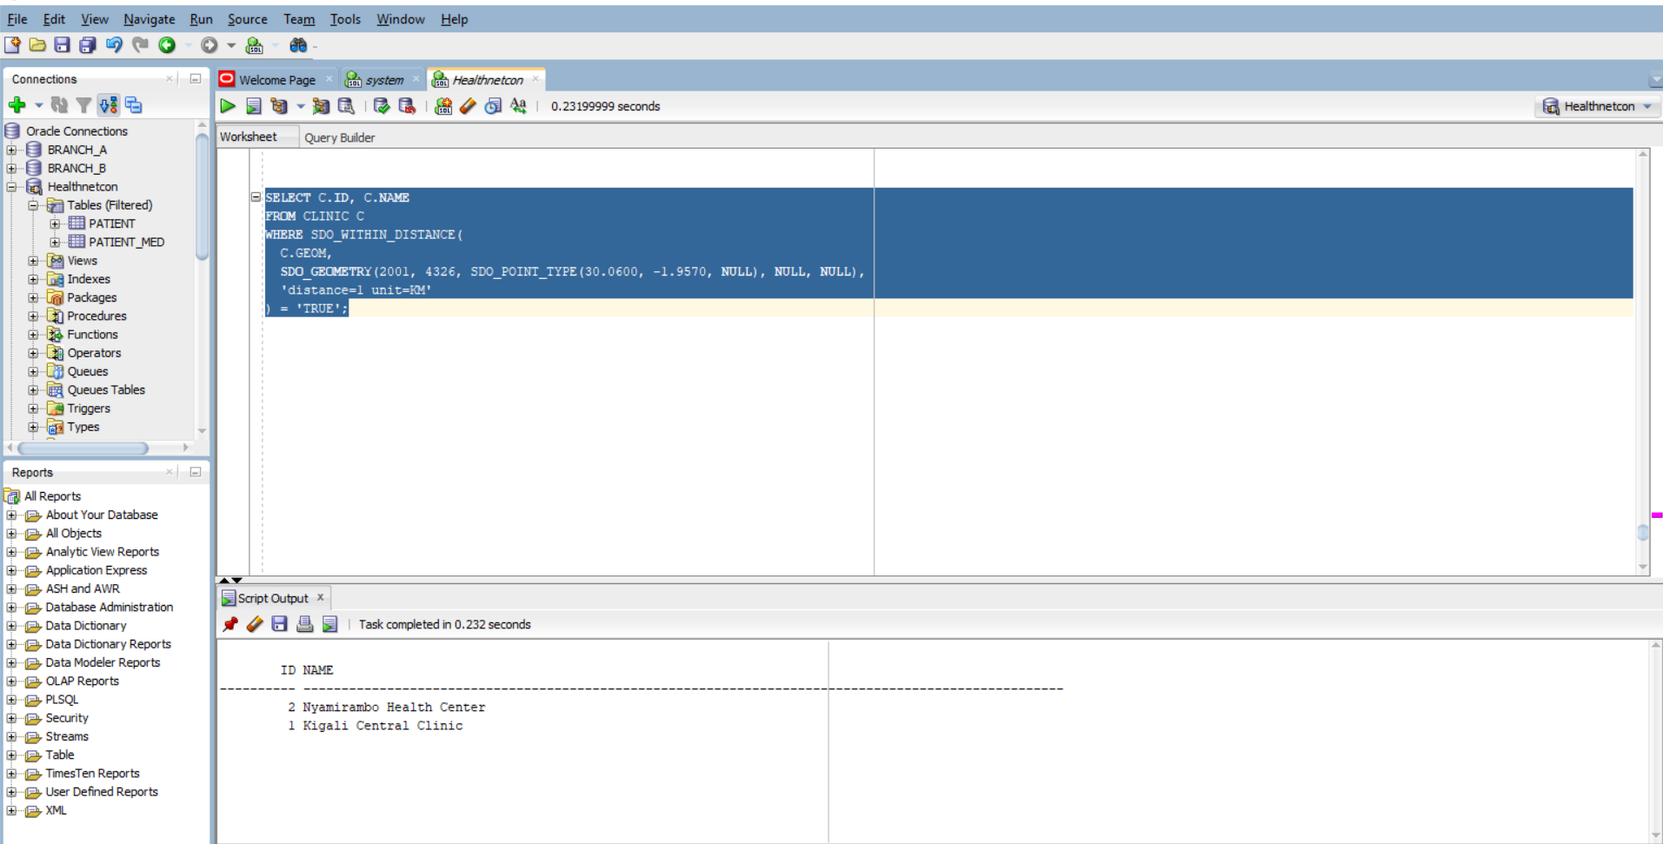

SELECT C.ID, C.NAME,
SDO_GEOM.SDO_DISTANCE(
C.GEOM,
SDO_GEOMETRY(2001, 4326, SDO_POINT_TYPE(30.0600, -1.9570, NULL), NULL, NULL),
0.005,
'unit=KM'
) AS KM
FROM CLINIC C
ORDER BY KM
FETCH FIRST 3 ROWS ONLY;

